PROJECT MANAGEMENT

  - FEASIBILITY STUDY:

    - Technical Feasibility: This phase of the feasibility analysis deals with the
computer-oriented feasibility of the system.
In our project using language like php, html, css, and js. We have created this sorts equipment project and have also used defferent types of tags in it have prepaid this project. And we have also includede photos defferent sports euipments in this project. And our site you can register to buy that product we put.

    - Operational Feasibility: The operational feasibility is always a totally peopleoriented approach.
Our sports equipment buying website is easy to operate for admin ,visitor and register user all of them.register user one click for give review, add to cart, place order, view product, search product only one click and few easy steps for registration for visitors.

    - Economical Feasibility: Some extra resources such as high capacity RAM, some
software that are time effective to use such as ‘PHP’, wamp Server and various other resources have been used, but they all are economic and can be used by anyone in an efficient way without worrying about much from an economic view.

  - PROJECT PLANNING:
2.2.1 Project Development Approach & Justification:

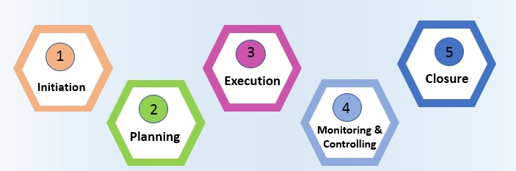
How use this model for developing this project
- In the initiation phase, you will define the project. You will sort out the project goals, scope, and resources of the project and what roles are needed on the team. Clarifying what stakeholders expect out of the project, and what exactly the project is aiming to achieve (and why) will give the project and team clear direction.
- In the planning phase, you will determine the steps to actually achieve the project goals—the “how” of completing a project. You will establish budgets, timelines, milestones, source materials, and necessary documents. This step also involves calculating and predicting risk, establishing change processes in place, and outlining communication protocols. If the initiation phase is assembling your troops, the planning phase is deciding what to do with them.
- Executing a project means putting your plan into action and keeping the team on track. Generally, this means tracking and measuring progress, managing quality, mitigating risk, managing the budget, and using data to inform your decisions. Specific steps might include:
  - Using tools like DFD and E-R or burndown charts to track progress on tasks
  - Responding to risks when they manifest
  - Recording costs
  - Keeping team members motivated and on task
  - Keeping stakeholders informed of progress
  - Incorporating changes via change requests
- In the closing phase of the project management lifecycle, you will conclude project activities, turn the finished product or service over to its new owners and assess the things that went well and did not go so well. It will also be a time to celebrate your hard work. Steps in the closing phase can include:
  - Conducting retrospectives and take notes of changes you can implement in the future.
  - Communicating to stakeholders at the end of the project and providing an impact report
  - Communicating with the new owners of a project.
  - Creating a project closeout report
  - Celebrating the end of the project and your successes
  - PROJECT SCHEDULING:
Scheduling in project management is the listing of activities, deliverables, and milestones within a project. A schedule usually includes a planned start and finish date, duration, and resources assigned to each activity. Effective project scheduling is a critical component of successful time management, especially for professional service businesses.

In this guide, we will explore the concept of scheduling in project management, its importance, and how it is done. We will also look into the different scheduling techniques, tools, and best practices that project managers can leverage to keep their projects on track and deliver successful outcomes.
If you are looking for a tool that will allow you to have full control over the scheduling processes for your projects, Wrike has the right solution for you. You can start today and unlock the full power of project management.
Resources required for Development of Project:
- Human effort
- Sufficient disk space on server
- Specialized hardware
- Software technology
- Travel allowance required by project staff, etc.
Advantages of Project Scheduling:
- It simply ensures that everyone remains on same page as far as tasks get completed, dependencies, and deadlines.
- It helps in identifying issues early and concerns such as lack or unavailability of resources.
- It also helps to identify relationships and to monitor process.
- It provides effective budget management and risk mitigation.

